Atria Institute of Technology



**Department of Information Science and Engineering**

**Big Data Analytics (18CS72)**

**Assignment-1**

**SUBMITTED BY**

Name: Syeda Afsa Tamim

USN:1AT20IS100

Section: B

Submission Date:29 -12-2023

**COURSE HANDLING FACULTY NAME:**

Dr. K S Ananda Kumar

Associate Professor

Dept of ISE, Atria IT.

**Table of contents**

|  |  |
| --- | --- |
| **Sl. No** | **Description** |
| 1 | 1. create an **EC2 Linux** instance in AWS Cloud /Any cloud  INSTANCE NAME - **YOUR NAME**  INSTANCE TYPE - t2.micro/any other also.  key pair name- your name  storage - 10 GB  Take the screenshot of instance running status  Mention the private IP address and Public IP address.  (Execute this program/concept and take a screenshot of the output) |
| 2 | Execute the basic Linux commands/ simple program on the instance  (Execute this program and take a screenshot of the output) |
| 3 | Create the **GitHub** Account with your credentials, Same things stored in public repository in Github. Share the assignment in github link. |

**Instance Creation-01**

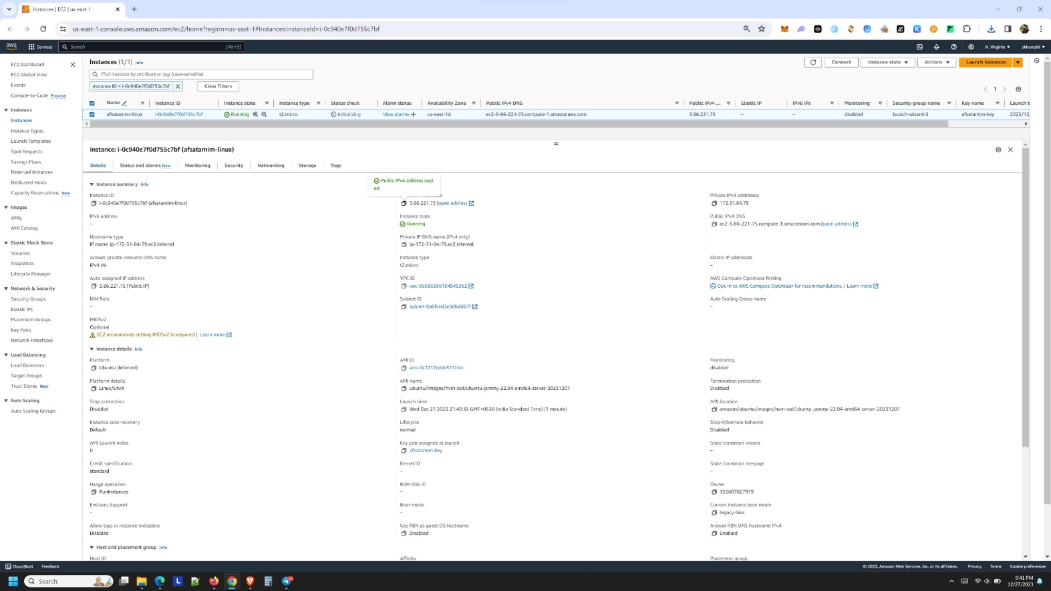SCREENSHOTS OF AWS INSTANCE

* Instance:

i-0c940e7f0d755c7bf (afsatamim-linux)

* Instance ID:

i-0c940e7f0d755c7bf (afsatamim-linux)

* Public IPv4 address:

3.86.221.75

* Private IPv4 addresses:

172.31.84.79

* Instance state:

Running

SCREENSHOTS OF AWS INSTANCE

SCREENSHOTS FROM puTTY-Setup

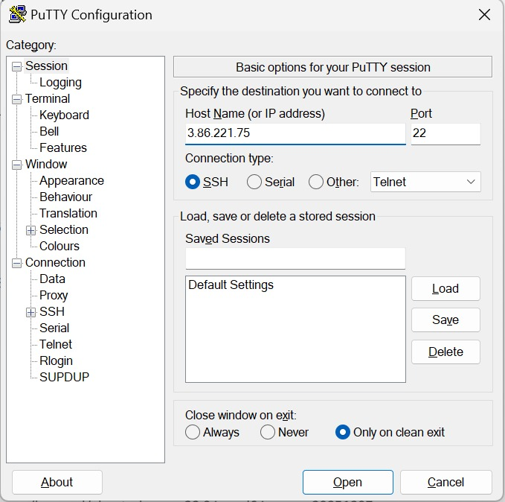

In putty under host name enter the Public IPv4 address.

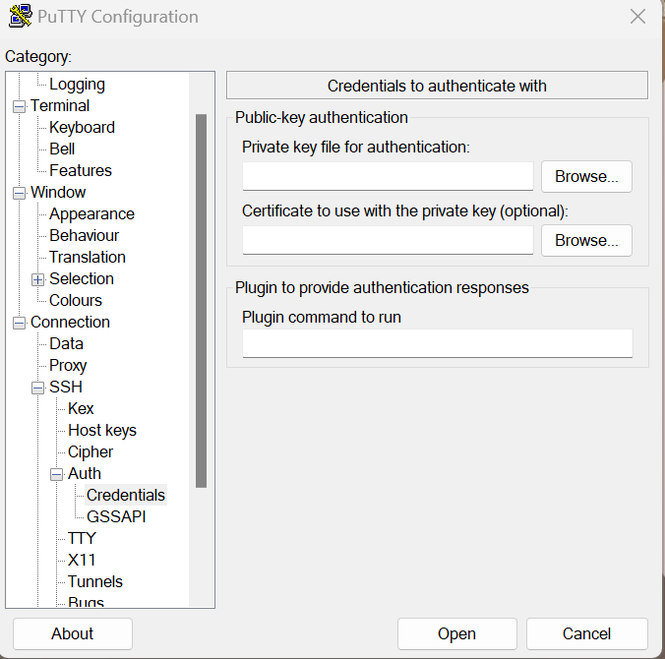

Under Auth in private key file for authentication browse and add the PuTTY Private Key File (.ppk) named afsatamim-linux.

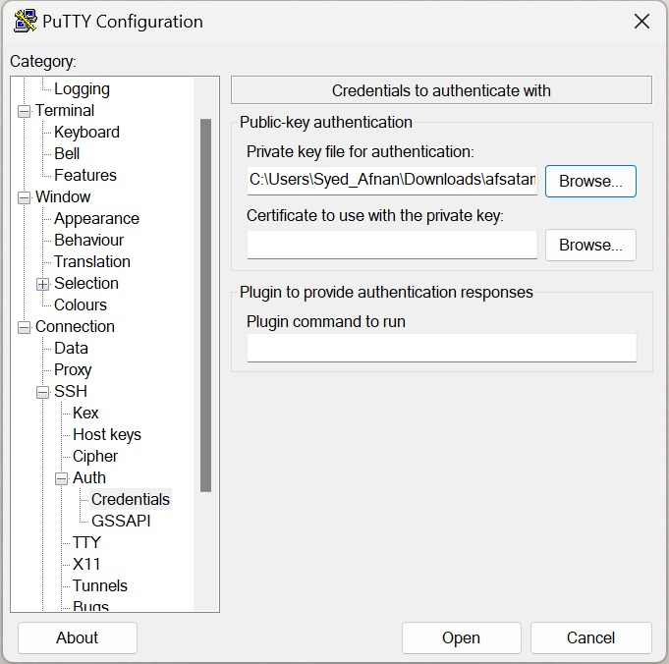

After browsing click on Open button

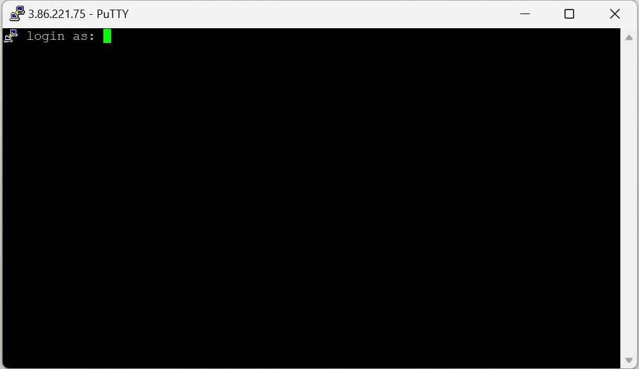

This directs us to this screen now enter the User name that is ubuntu

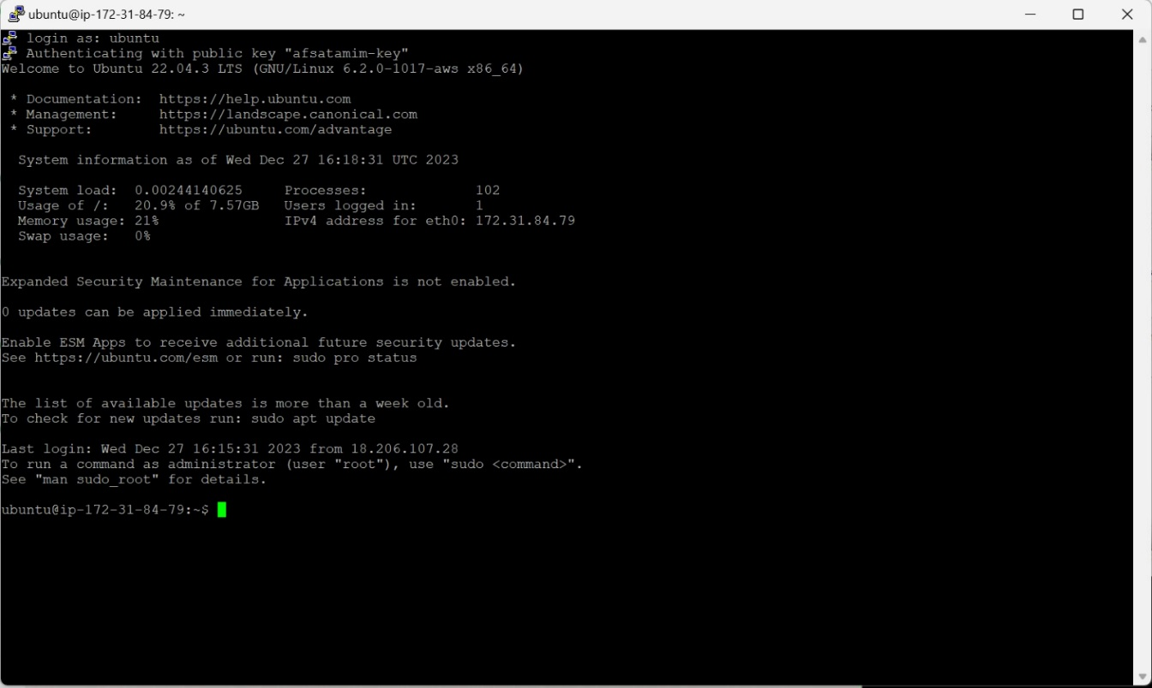

Ater successful login it authenticates and now we can enter any commands.

SCREENSHOTS FROM puTTY-commands

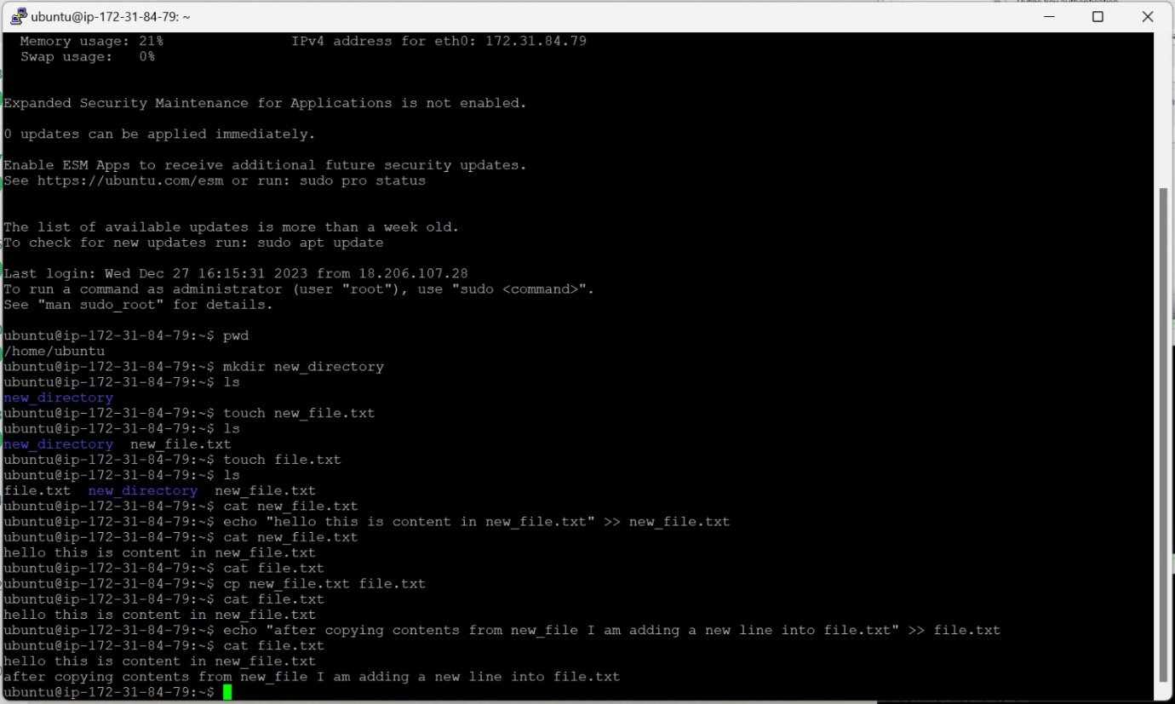

* pwd:

pwd is used to present working directory, this gave the output /home/ec2-user

* mkdir:

The mkdir (**m**a**k**e **dir**ectory) command creates a new directory in the provided location. I have created a directory called new_directory .

* ls:

The ls command (**l**i**s**t) prints a list of the current directory's contents. Therefore we got the directory created display as output.

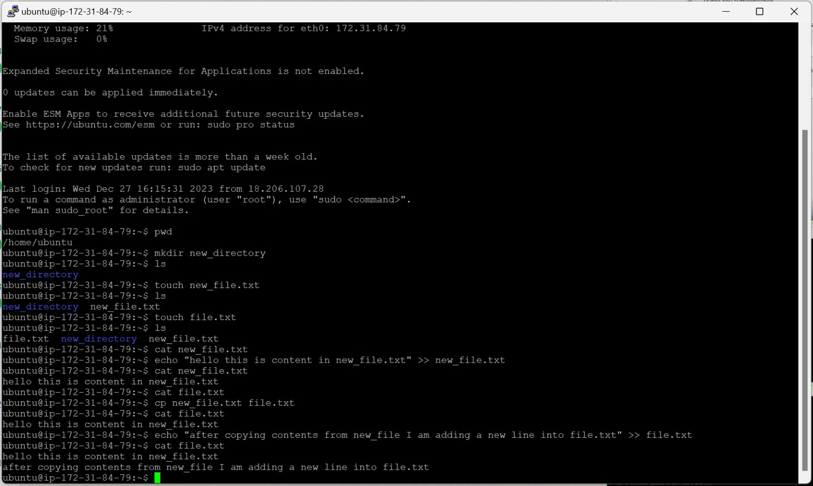

* touch:
* The touch command's primary purpose is to modify an existing file's timestamp. The command creates an empty file if it does not exist. Due to this effect, touch is also a quick way to make a new file (or a batch of files).
* Here I have created a txt file called new_file first then a second txt file called file_txt.
* Using ls command we can find where these files have been created .
* cat:
* The cat command (con**cat**enate) displays the contents of a file in the terminal (standard output or stdout).
* To use the command, provide a file name from the current directory.
* Here I provide the txt file called new_file.txt.
* echo:
* The echo command to print arguments to the terminal.
* Here I have used echo “hello this is the content in new_file.txt”.
* The >> operator redirects output to a file.

Later I use cat to find the content in new_file.txt. Therefore we can see that “hello this is the content in new_file.txt” has been added to new_file.txt



cat file.txt is executed to show that there is no content in file.txt.

* cp:
* The main way to copy files and directories in Linux is through the cp (**c**o**p**y) command. cp <source file> <target file>.
* The source and target files must have different names since the command copies in the same directory. Provide a path before the file name to copy to another location.
* Here we are copying the content of new_file.txt into file.txt using cp [cp new_file.txt file.txt]
* Then when we use cat on file.txt it shows “hello this is the content in new_file.txt” so content is successfully copied.
* Now we make use of echo and >> to add a new line in file.txt i.e “after copying contents from new_file I am adding a new line into file.txt”.
* Now when cat is used on file.txt both are lines are given as output.

**Assignment GitHub Link:**

https://github.com/syedaasfa/bda-assignment